List of classes written to implement the game:

main.cpp

The main driver of the program. It calls on Graphics.cpp, GameEngine.cpp, MusicPlayer.cpp, GameController.cpp, and PhysicsEngine.cpp to create the game, and run it.

GameEngine.h

The logic of the game is handled in this class. It uses Graphics.h, PhysicsEngine.h, MusicPlayer.h, and GameController.h to properly update the state of the game.

Graphics.h

This class renders the air hockey game including the table, puck(s), and paddles. It’s also responsible for the scoring text shown on the screen. Assimp is used to load the textures for the game.

PhysicsEngine.h

Collisions in the game, primarily how the puck interacts with the paddles and the walls of the table, are done in this class. The Bullet library was used to handle collisions between bodies and how they would react.

MusicPlayer.h

This class stores the songs and sounds used for the game. It also handles, pausing, going to the next song, and playing the song. “#include <SFML/Audio.hpp>” was used to play the WAV files loaded.

GameController.h

This class handles PS4 controller compatibility. “#include <SFML/Window.hpp>” was used to access joystick axis for its use in the game.

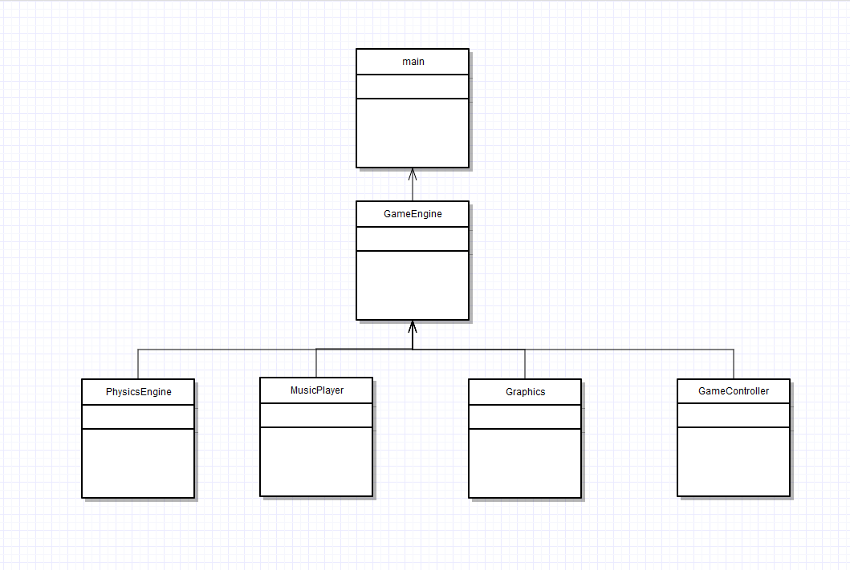

Issues: Unexpected seg faults occurred with older versions of VMWare. The team had to downgrade to previous versions to avoid them.